## University of the People

## Writing Assignment Unit 5

## CS 2401 - Software Engineering 1

## March 2 ,2023

The Classic Triangle Testing Problem, (Myer's Triangle): A program reads three integer values. The three values are interpreted as representing the lengths of the sides of a triangle. The program prints a message that states whether the triangle is scalene, isosceles, or equilateral.

Let **a**, **b**, and **c** be the three lengths of the triangle.   
The conditions to be considered for the test triangle can be as follows:

* The values of a, b, and c can never be equal to 0.
* If it one or more of the values is 0, then, it is not a triangle.
* If all three values of the triangle a and b and c are not equal to each other, it is scalene.
* If two of the three values are equal to one another, it is isosceles.
* If all three values are the same, it is equilateral.
* The value will only be valid for positive integers.

And the program code to test the triangle problem can be as follows:

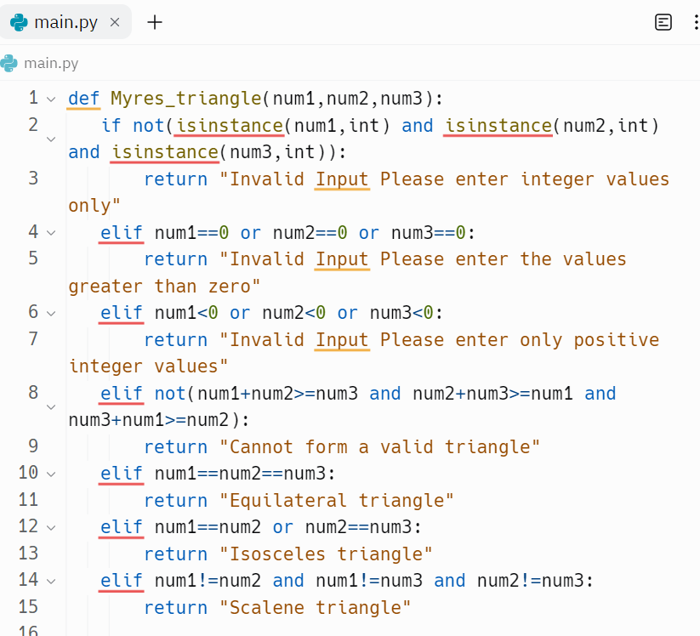

And we can develop a set of test cases (at least 6) that will adequately test this program as follows*.*

Inputs

Outputs

**Reference**

Marsic, I. (2012). *Software engineering.* Rutgers Unversity. [**http://www.ece.rutgers.edu/~marsic/books/SE/book-SE_marsic.pdf**](http://www.ece.rutgers.edu/~marsic/books/SE/book-SE_marsic.pdf).